APA MEMBERSHIP PACK
Member In Training

Association for Psychological Accreditation

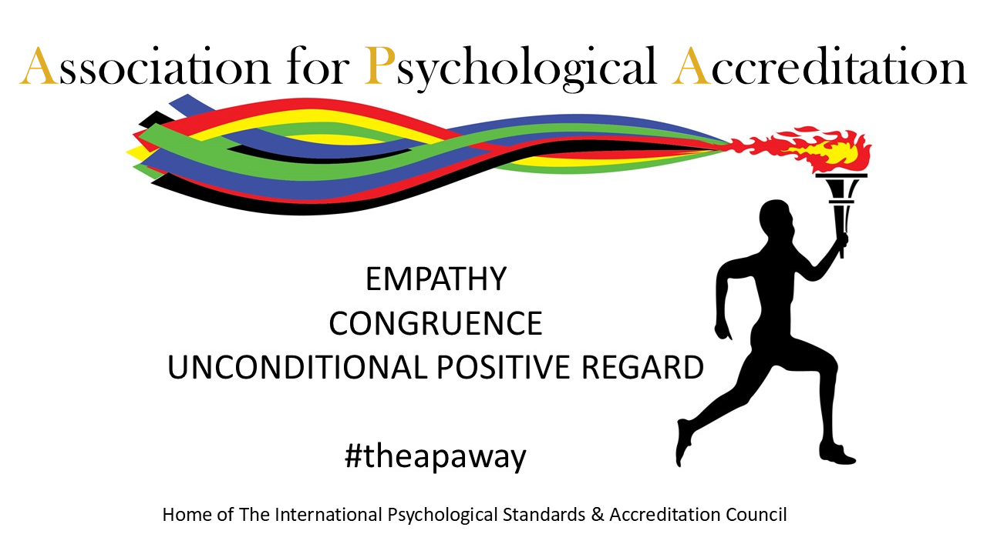

APA Membership Application

Membership by Members for Members

Full Name: _______________________________________________
Home Address: _______________________________________________
_______________________________________________
_______________________________________________
Email: _______________________________________________

Contact Telephone: ______________________________________________
- Will you be requesting Supported Membership status?

Yes No

- Have you read the APA Membership Guide?

Yes No

- Do you agree to and permit the APA Membership Team to carry out the Membership Assessment based on the information within your application?

Yes No

Date of Application: ____________________________

Section 2

Member In Training
Proof of Identity | Proof of course
Any Certificates already received | Evidence of Supervision arrangements
1000-word Essay | Completed Application Form
What you need to send.

Qualification being Studied: ___________________________________________________
Dates of Course:
Starts __________________ Finishes ____________________
Place of Study: ____________________________________________
Details of Placements completed:
Organisation: | Date of Placement: | Location of Placement: | Contact details for Placement:  Name, email and Telephone

Please detail all psychologically based / Therapeutic qualifications
Qualification: | Date of Qualification: | Qualifying Body: | Place of Study:

Do you have multiple supervisors?

Yes No

Average Total Monthly Supervision provision: _______________________________

Please give details of your Primary Supervision contract.
Average Monthly Primary Supervision provision: _____________________________
Name of Supervisor: ___________________________________________________
Telephone No. ___________________________________________________
Email: ___________________________________________________
If your Supervisor is an APA Member, please give their Membership Number

Go to Profile Submission

Section 3:
Profile Submission
This will make up your Profile listing on the APA Directory
Name:
Location:
Website:
Biography:

Membership Type |  | Holds a DBS / Disclosure Certificate
Holds a Supervisors Certificate

Signature: ____________________________
Go to Section 4

Section 4:
Self-Awareness Statement
How do you utilise self-awareness? (300-word limit)

Section 4:
Self-Awareness Statement Cont’d…
How do you utilise self-awareness?

Section 5: Submission Declaration & Authorisations
I _______________________ confirm, that the information provided in my application is true and accurate. I hereby accept and agree to abide by the APA Terms and Conditions, Ethical and Professional Protocols and the Specific requirements of my chosen Membership category.
In signing this declaration, I authorise the Association for Psychological Accreditation to commence their Membership Assessment. I am fully aware that this includes, confirming the details contained within my application. I therefore, give consent for APA to contact those persons named within the Application.
I have included all required components of my application and understand that the process will include a verbal ‘Conversation of Discovery’ with a member of the APA Membership Assessment Team. I acknowledge that the ‘Conversation of Discovery’ is intended to provide an opportunity to demonstrate my capacity for self-awareness, and capability to support my clients and the wider therapeutic community.
I accept that any attempt on my part to mislead, deceive or manipulate the application process will result in the immediate termination of my application.
I accept that unless specified by myself, in writing, my APA Membership will be a rolling membership and my membership fee will continue to be paid as agreed in this application.
Attachments and Inclusions with my Application

I confirm my desire and intent to become a Member of the Association for Psychological Accreditation.
Proof of Identity |  | DBS / Disclosure Certificate  If required
Proof of Address |  | Permit to Work  If required
Proof of Study  (MIT only) |  | Evidence of Supervision  (QAM & MIT only)
How to utilise self-awareness in your therapeutic practice (1000-word limit)  (QAM & MIT only) |  | Evidence of Placement
Section 4 of this Application  All Applicants |  | Evidence for Supported Membership Status

Signed: _____________________________________
Date: __________________________________________

A new approach for
new results

Contact us
- By telephone: Call our customer service team on 0208 556 4984
- By email: support@apa-accreditation.co.uk
- In writing: Ayanay Psychological Accreditation,
11 – 13 Cambridge Park, Wanstead, London E11 2PU

