APA’s
Ethical & Psychological Awards
The Nomination Form

Ayanay Psychological Accreditation

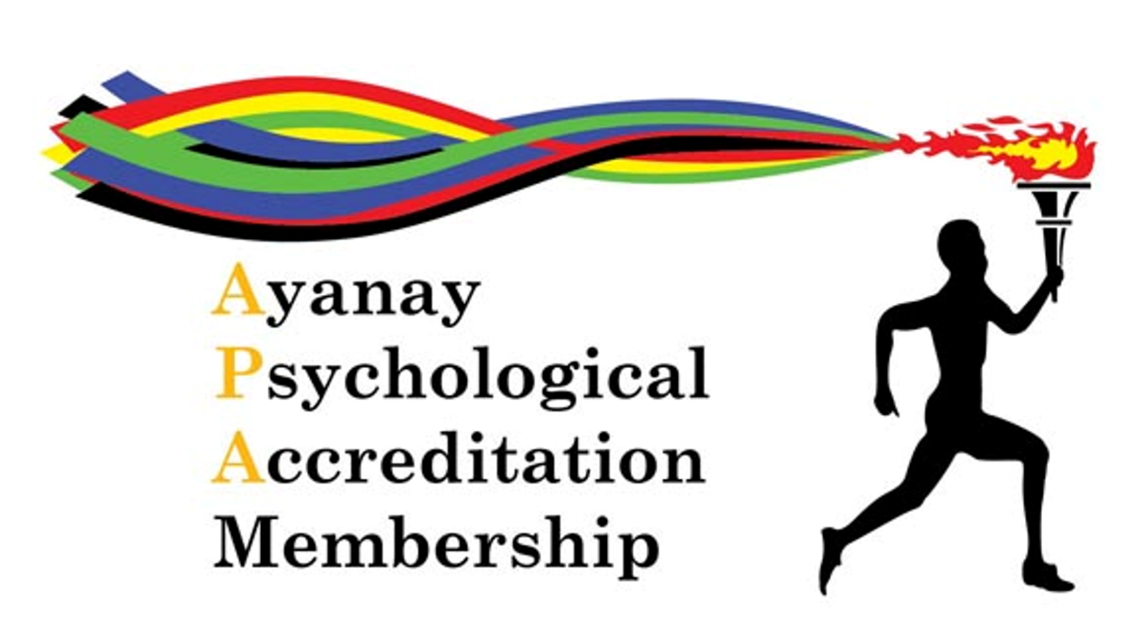

The APA
Ethical & Psychological Awards

We aim to empower and encourage businesses, charities and all organisations to work to improve the psychological wellbeing of their teams. These awards are intended to recognise and celebrate this work and achievement. No more hoop-jumping or box-ticking.
APA’s ethos is to drive solutions that work for the benefit of those in need, at the time of need. We seek to encourage growth of best practice and effective mental health support in the workplace.

The APA Awards Panel is made up of therapeutic professionals, business consultants and HR professionals.

The Categories

Wellbeing Excellence in the Workplace
Nominations for this award are open to businesses, charities and organisations, that are able to demonstrate their systematic processes and responses to concerns of psychological wellbeing. The Awards Panel will verify and endorse those applications or offer the business a comprehensive Support Framework that allows for enhanced support for their employees.

The APA Contribution Award
Businesses, charities and organisations are invited to nominate individuals from within their teams, who have made an outstanding contribution to the development and improvement of psychological wellbeing in the workplace.

The Youth Engagement Award
This Award recognises the dedicated efforts of Companies, Organisations, Charities and individuals, to enhance, develop and grow the positive Mental health of young people around the world.
The Adrian Pennington Award
Recognising the Future Talent of the Psychological Sector. APA celebrates those stand out students that not only embrace the teachings of the past, are eager to learn in the present, but are also the ‘Torch bearers’ of the future.

The Directors Award
This will be awarded by the APA Directors to individuals for outstanding contributions to the advancement of psychological understanding and professional development.

The APA 20:20 Vision Award
The APA Award for Ethical & Psychological best practice in the Workplace.
Every Ethical & Psychological Award winner will be eligible for the Annual APA 20:20 Vision Award.

The Ethical & Psychological Award for
Wellbeing Excellence in the Workplace

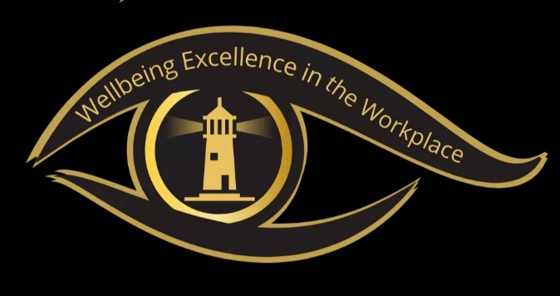
Ethical and Psychological Wellbeing is the next level of Mental Health understanding.
For a long time, businesses, charities and organisations have been led by outside agencies, in regard to the appropriate response to incidents, challenges and issues around mental health in the workplace.
This award is designed to allow and encourage effective development of processes, for positive and functional responses that increase the positive mental health of teams and to support team members in times of need.
Without prescribing a generic framework for businesses, charities or organisations, that APA has no detailed or working knowledge of, is, in our belief, a smarter way of allowing these groups to identify need and develop effective solutions for their working environment and the people they work with.
The Wellbeing Excellence in the Workplace Award is open to ANY business, charity or organisation that:
- Actively provides its teams with mental health support.
- Has developed effective responses to issues concerning mental health.
- Operates positive working practices to reduce mental health challenges.
- Has taken measures to improve the overall psychological wellbeing of its teams.
Yes, that’s right, we are not going to tell you, how to respond to the needs within your workplace. You know what works for you and your teams. APA wishes to have the examples of excellence recognised and celebrated.
Submissions for the Wellbeing Excellence in the Workplace Award carries a cost as the submission must be verified and assessed by The Awards Panel.
Any submission that The Awards Panel feel can benefit from their knowledge, experience and guidance, in relation to enhancing the workplace wellbeing for the submitting party and their teams, will receive an Ethical & Psychological Support Guide.
Recipients of The Award will automatically be Finalists in the Ethical & Psychological 20:20 Vision Award in this Category. All finalists receive Digital recognition at no cost. APA does offer an Elevated Recognition package including a Physical Award and a featured article in The APA Newsletter and Video promotion on the APA YouTube Channel.

The Contribution Award for Enhanced Wellbeing

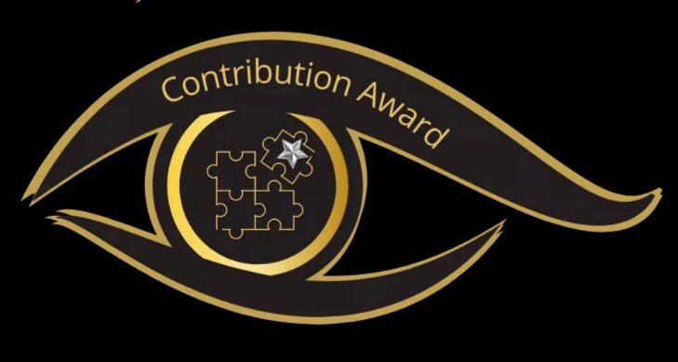
Businesses, charities and organisations will always benefit from the driving commitment and passion of its team members.

Often the contribution of individuals can be over looked in the development of new processes, protocols and workplace responses to issues of mental health.

The APA Contribution Award invites businesses, charities, and organisations to nominate individuals from within their teams, who have made an outstanding contribution to the development and improvement of Psychological wellbeing.

At APA we acknowledge the importance of teams in developing and enhancing wellbeing, we also understand that in many environments a single person can be the catalyst that sparks that development. This award celebrates those individuals, their commitment and focus to bring about positive change in the workplace, for the benefit of the whole workplace. This award allows businesses, charities and organisations, to recognise and celebrate the innovation, creativity, consideration and foresight of an individual, beyond the confines of their own working environment. This promotes best practice, stimulates development and shows the dedication of the management team, to acknowledge and celebrate the efforts, taken to improve mental health.

Yes, that’s right, we are not going to tell you, who should be rewarded or not. You know whose contribution has benefited you and your teams. You know the impact a compassionate, inspired and motivated individual has had on your teams. When these energies are focused on the development of positive wellbeing in the workplace, amazing results can be achieved, not only for your teams but the overall business as well. APA wishes to have the examples of this focus and commitment to improving the workplace wellbeing, recognised and celebrated.
Any submission that The Awards Panel feel can benefit from their knowledge, experience and guidance, in relation to enhancing the workplace wellbeing for the submitting party and their teams, will receive an Ethical & Psychological Support Guide.
Recipients of The Contribution Award will automatically be Finalists in the Ethical & Psychological 20:20 Vision Award in this Category. All finalists receive Digital recognition at no cost. APA does offer an Elevated Recognition package including a Physical Award and a featured article in The APA Newsletter and Video promotion on the APA YouTube Channel.

The Youth Engagement Award

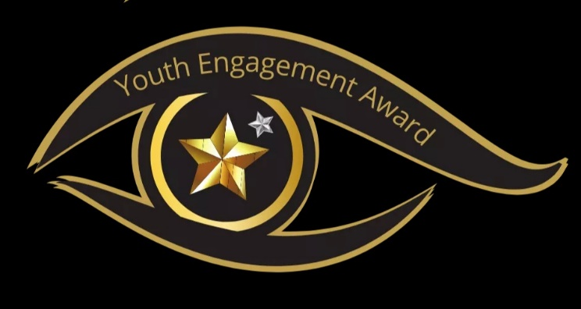
This Award recognises the dedicated efforts of Companies, Organisations, Charities and individuals, to enhance, develop and grow the positive Mental health of young people around the world.

As the world responds to recent events, it is crucial that efforts are focused on ensuring young people are included in the development, and delivery of solutions just as, is the need to ensure the psychological well-being of young people is protected, nurtured and allowed to flourish.

APA is delighted to showcase the outstanding work being done to support youth engagement in the community. Nominations for The Youth Engagement Award are open to Organisations, Charities, Community Groups, and individuals.

Any submission that The Awards Panel feel can benefit from their knowledge, experience and guidance, in relation to enhancing the workplace wellbeing for the submitting party and their teams, will receive an Ethical & Psychological Support Guide.
Recipients of The Youth Engagement Award will automatically be Finalists in the Ethical & Psychological 20:20 Vision Award in this Category. All finalists receive Digital recognition at no cost. APA does offer an Elevated Recognition package including a Physical Award and a featured article in The APA Newsletter and Video promotion on the APA YouTube Channel.

The Adrian Pennington Award

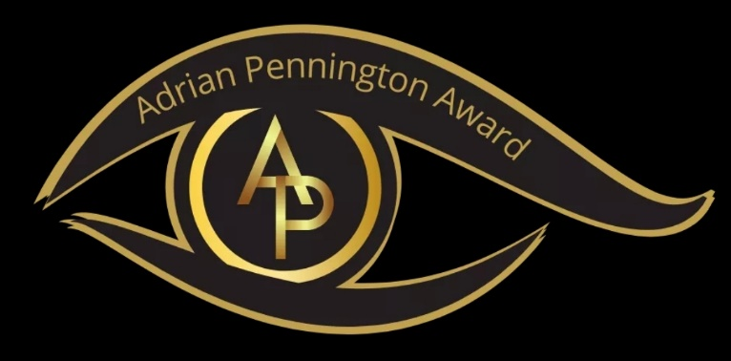
Recognising the Future Talent of the Psychological Sector. APA celebrates those stand out students that not only embrace the teachings of the past, are eager to learn in the present, but are also the ‘Torch bearers’ of the future.
The late Adrian Pennington served the therapeutic community for over 30 years. A phenomenal practitioner who had a passion for the power of therapy. Adrian authored The Student Guide to Counselling & Psychotherapy Approaches as a reflection of his commitment to enhancing the student experience. Adrian dedicated much of his professional career to supporting, guiding and supervising the talent of the therapeutic community.
APA’s CEO Vonnie Crosbie says of Adrian, “Adrian was a wonderful teacher who encouraged me to allow the ripples of his impact on myself to spread to others as I do. You couldn't ask for a wiser more caring therapist than Adrian Pennington. May he RIP.”
APA is proud to present the Adrian Pennington Award to those Students that shine as the Future Talent of the Psychological Sector.
Nominations for this Award can be made by Education and Placement Providers only.
Any submission that The Awards Panel feel can benefit from their knowledge, experience and guidance, in relation to enhancing the workplace wellbeing for the submitting party and their teams, will receive an Ethical & Psychological Support Guide.
Recipients of The Adrian Pennington Award will automatically be Finalists in the Ethical & Psychological 20:20 Vision Award in this Category. All finalists receive Digital recognition at no cost. APA does offer an Elevated Recognition package including a Physical Award and a featured article in The APA Newsletter and Video promotion on the APA YouTube Channel.

The APA Directors Award

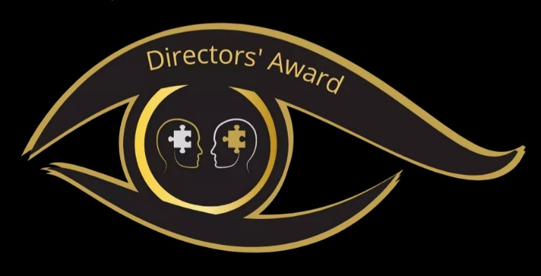
This will be awarded by the APA Directors to individuals for outstanding achievements and contribution to the advancement of psychological understanding and professional development.

APA acknowledges the importance of ever evolving knowledge and research in the multiple areas of psychology, just as in the various modalities of psychological support. Therefore, The Directors Award will be open to all disciplines and modalities, this includes Academics, Therapeutic Professionals, Coaches, Business Leaders, Educators, Social Cohesion Professionals, and Young People for example.

The APA Directors welcome nominations from APA Members and members of the public. The Awards Panel will review all nominations and make a final selection for the APA Directors to make their final choices.

Nominations placed before the APA Directors will be contacted directly, by The APA Awards Panel and notified of their selection. With details of the successful recipients being announced on the 4th July each year, as part of APA’s Birthday celebrations.

Recipients of The Directors Award will automatically be Finalists will in the Ethical & Psychological 20:20 Vision Award in this Category. All finalists receive Digital recognition at no cost. APA does offer an Elevated Recognition package including a Physical Award and a featured article in The APA Newsletter and Video promotion on the APA YouTube Channel.

The APA 20:20 Vision Award

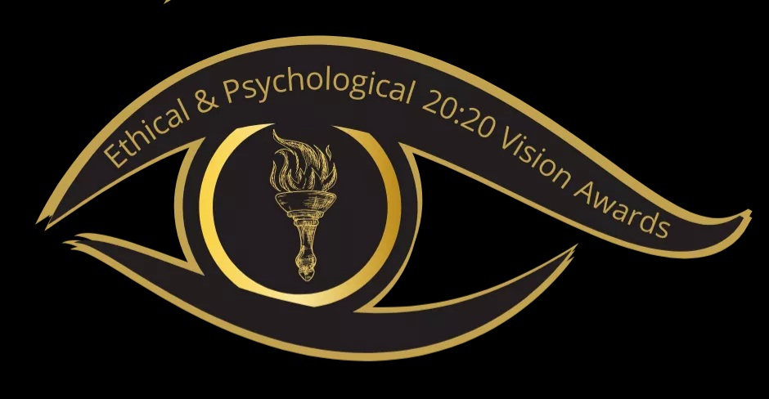

All Ethical & Psychological Category Award holders will be finalists for the Annual APA 20:20 Vision Awards. Highlighting and promoting best practice for the benefit of all, is the ultimate aim of the 20:20 Vision Award.

Showcasing positive mental health responses and operational wellbeing in the workplace and in the community, is an effective component in the development of positive, profitable and cohesive mental health awareness for everyone in all environments.

Voting for The 20:20 Vision Awards will be open from the 1st October till the 1st December with the winners being announced at the End of Year Event

Promoting the stand out example of Ethical and Psychological Best Practice in the workplace will not only benefit the winner, by way of employee and client attraction, but also showcase how others can increase and enhance their operational delivery, for the benefit of all. This will ensure an ever-evolving development of positive practice in the workplace.

APA’s Ethical & Psychological 20:20 Vision Award Winners receive Digital recognition, and a featured article in The APA Newsletter and Video promotion on the APA YouTube Channel. at no cost. APA does offer an Elevated Recognition package including a Physical Award and on-going promotion.

Submissions and Nominations:

Company Statement on Mental Health. | Examples of peer to peer, positive / motivational communication.
Evidence of policies relating to Mental Health in the workplace. | Examples of policies in practice.
Team Testimonials of good practice. | Completed Submission Form and Payment.
The Wellbeing Excellence in the Workplace
What you need to send?
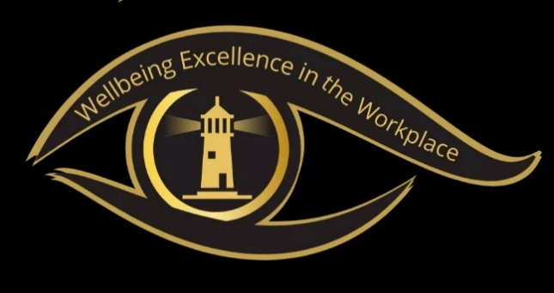

Full Name: _______________________________________________
Of person making the submission:

Name of:
Business _______________________________________________
Charity _______________________________________________
Organisation _______________________________________________
Address: _______________________________________________
_______________________________________________
_______________________________________________
Website: _______________________________________________
Email: _______________________________________________
Of person making the submission:
Contact Telephone: ______________________________________________
Of person making the submission:

If the person making the submission is an APA Member please provide your APA Membership Number: ________________________

The Contribution Award for Enhanced Wellbeing
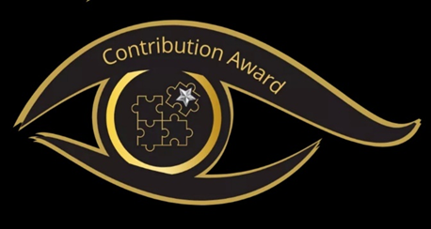
What you need to send?
Written company statement on the individuals contribution/s. | Video endorsement of the individual’s contribution.
Evidence of the positive impact on Mental Health. | Examples of the contribution in practice.
Testimonials of positive outcomes as a result of the contribution/s.

Name: _______________________________________________
Of person being nominated:
Name: _______________________________________________
Of person making the submission:

Name of the Business, Charity, or Organisation

_______________________________________________

Address: _______________________________________________
_______________________________________________
_______________________________________________
Website: _______________________________________________
Email: _______________________________________________
Of person making the submission:
Contact Telephone: ______________________________________________
Of person making the submission:
If the person making the submission is an APA Member please provide your APA Membership Number: ________________________

The Youth Engagement Award
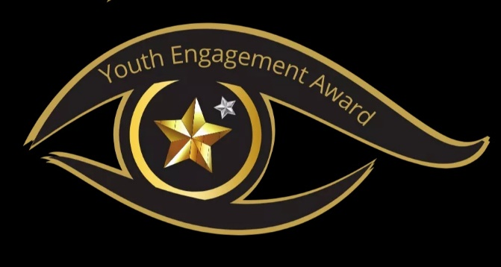
What you need to send?
Written statement on the contribution/s. | Video endorsement of the contribution.
Evidence of the positive impact on Mental Health. | Examples of the contribution in practice.
Testimonials of positive outcomes as a result of the contribution/s.

Name: _______________________________________________
Of person Business, Charity, or Organisation being nominated:
Name: _______________________________________________
Of person making the submission:

Address: _______________________________________________
_______________________________________________
_______________________________________________
Website: _______________________________________________
Email: _______________________________________________
Of person making the submission:
Contact Telephone: ______________________________________________
Of person making the submission:
If the person making the submission is an APA Member please provide your APA Membership Number: ________________________

The Adrian Pennington Award
What you need to send?
Written statement on the students Talent | Video endorsement of the individual’s Talent.
Evidence of their positive impact on Mental Health.
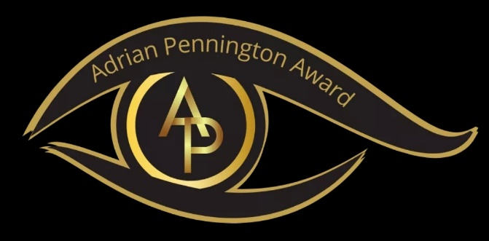

Name: _______________________________________________
Of person being nominated:
Name: _______________________________________________
Of person making the submission:

Name of the Business, Charity, or Organisation

_______________________________________________

Address: ______________________________________________
_______________________________________________
_______________________________________________
Website: _______________________________________________
Email: _______________________________________________
Of person making the submission:
Contact Telephone: ______________________________________________
Of person making the submission:
If the person making the submission is an APA Member please provide your APA Membership Number: ________________________

The APA Directors Award

What you need to send?
Written statement on the achievement or contribution/s to be recognised. | Optional Video endorsement of the individual’s achievement or contribution.
Completed Submission Form.
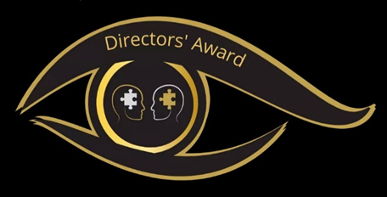

Name: _______________________________________________
Of person being nominated:
Name: _______________________________________________
Of person making the nomination:

Summary of why your nominee stands out for The Directors Award.
________________________________________________________________________________________________________________________________________________________________________________________________________________________________________________________________________________________________________________________________________________________________________________________________________________________________________________________________________________________________________________________________________________________________________________________________
(please continue on a separate sheet if needed)

Email: _______________________________________________
Of person making the submission:
Contact Telephone: ______________________________________________
Of person making the submission:
If the person making the submission is an APA Member please provide your APA Membership Number: ________________________

A new approach for
new results

Contact us
By telephone Call our service team on 0208 556 4984

By email info@ayanay.co.uk

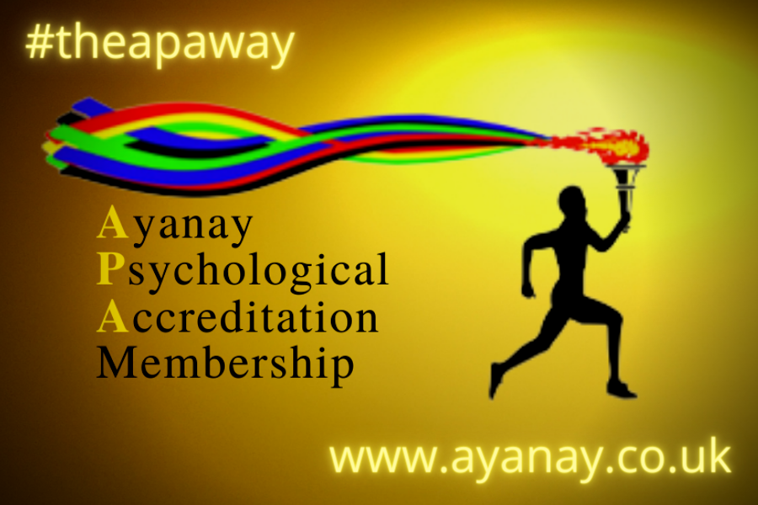
In writing APA Ltd, 10 The Shrubberies, South Woodford, London, E18 1BD

