APA MEMBERSHIP PACK
Qualified Accredited Membership

Association for Psychological Accreditation

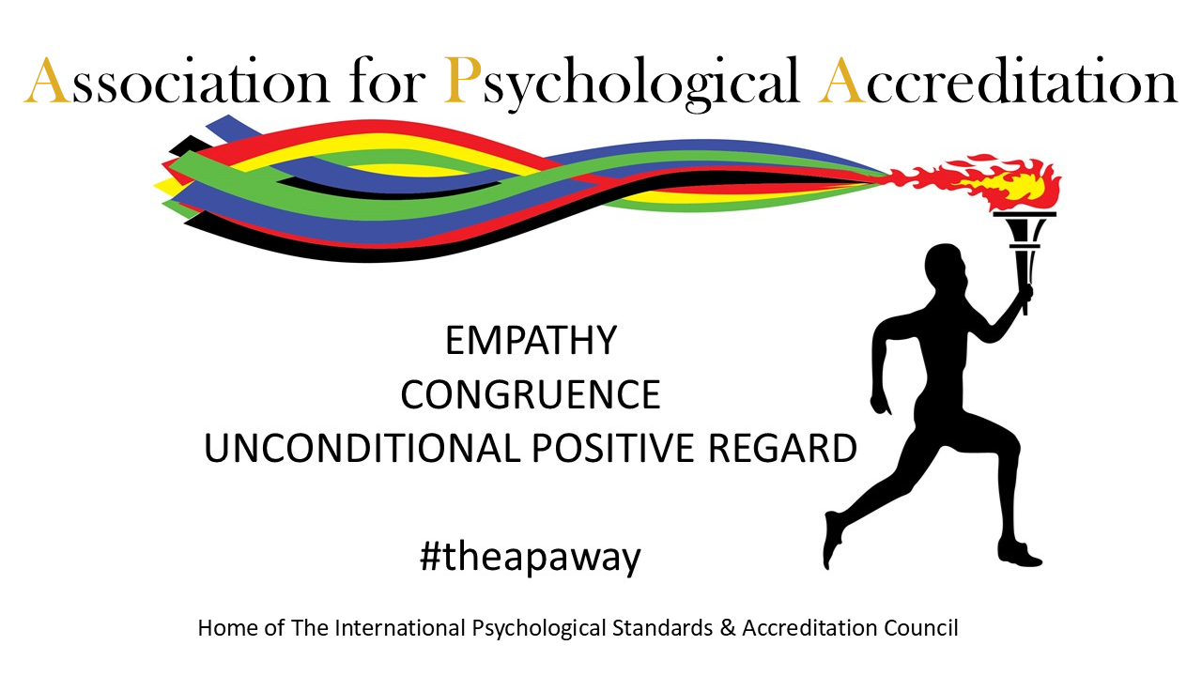

APA Membership Application

Membership by Members for Members

Full Name:
Home Address:
Email: _______________________________________________

Contact Telephone: ______________________________________________
- Will you be requesting Supported Membership status?

Yes No

- Have you read the APA Membership Guide?

Yes No

- Do you agree to and permit the APA Membership Team to carry out the Membership Assessment based on the information within your application?

Yes No

Date of Application: ____________________________

Section 2

Qualified Accredited Member
What you need to send?
Proof of Identity | Proof of Qualifications
Evidence of Insurance | Evidence of Supervision
1000-word Essay | Completed Application Form

2a Qualified Accredited Member Overview
Highest Qualification:
Date of Qualification:
Qualifying Body:
Do you work with children and / or vulnerable adults?
Yes No

If yes. Please give details of your DBS / Disclosure Scotland Certificate.
Date of Certificate: _______________________
Ref / Cert Number: _______________________
Please ensure to include a digital copy of your certificate with your application.

Do you intend to work with children and / or vulnerable adults in the next 12 months?
Yes No

Employed go to 2b
Private Practice go to 2c

Both go to 2d
I confirm I have attached my own Essay reflecting my therapeutic knowledge, understanding and how I apply that in my therapeutic work?
Yes

2b Qualified Accredited Member (Employed)
Please detail all psychologically based / Therapeutic qualifications
Qualification: | Date of Qualification: | Qualifying Body: | Place of Study:

Name of Employer: ________________________________________
Named Contact: ________________________________________
Telephone No. ________________________________________
Address of your place of work: ___________________________________
___________________________________
Website of your Employer: ___________________________________
Your Position: ________________________________________
Length of Service: ________________________________________
Please give a brief description of your role:
________________________________________________________________________________________________________________________________________________________________________________________________________________________________________________________________________________________________________________________________________________________________________________________________________________________________________________________________________________________________________________________________
- Is your role dependant on your accreditation status?

Yes No

- Does your role include dedicated supervision?

Yes No Please attach details of the supervision provision

- If yes, does this supervision come from your line manager?

Yes No

- Do you have a dedicated supervisor/s external to any employer provision?

Yes No

Please give details of any such Supervision contract.
Name of Supervisor: ___________________________________________________
Telephone No. ___________________________________________________
Email: ___________________________________________________
If your Supervisor is an APA Member, please give their Membership Number

- Do you have independent Insurances in place for your Therapeutic work?

Yes No

If Yes, Please provide copies as an attachment to your application

Go to Profile Submission

2c Qualified Accredited Member (Private Practice)
Please detail all Psychologically based / Therapeutic qualifications
Qualification: | Date of Qualification: | Qualifying Body: | Place of Study:

Name of Your Business:
Telephone No.
Address of your place of work: ___________________________________
___________________________________
___________________________________
Website of your Business:
Your Title:
How long have you been in Private Practice?
Please give a brief description of your methods of working:

- Do you have multiple supervisors?

Yes No

Average Total Monthly Supervision provision:
Please give details of your Primary Supervision contract.
Average Monthly Primary Supervision provision:
Name of Supervisor:
Telephone No. ___________________________________________________
Email: ___________________________________________________
If your Supervisor is an APA Member, please give their Membership Number

- Do you have Insurances in place for your Therapeutic work?

Yes No

If Yes, Please provide copies as an attachment to your application

Go to Profile Submission

2d Qualified Accredited Member (Dual Operation)
Please detail all psychologically based / Therapeutic qualifications
Qualification: | Date of Qualification: | Qualifying Body: | Place of Study:

Name of Employer: ________________________________________
Named Contact: ________________________________________
Telephone No. ________________________________________
Address of your place of work: ___________________________________
___________________________________
___________________________________
Website of your Employer: ___________________________________
Your Position: ________________________________________
Length of Service: ________________________________________

Please give a brief description of your role:
_____________________________________________________________________________________________________________________________________________________________________________________________________________________________________________________________________________________________________________________________________________________________________________________________________________________________________________________________________________________________________________________________________________

Name of Your Business: ________________________________________
Telephone No. ________________________________________
Address of your place of work: ___________________________________________________________________________
Website of your Business: ___________________________________
Your Title: ________________________________________
How long have you been in Private Practice? ________________________
Please give a brief description of your methods of working:
________________________________________________________________________________________________________________________________________________________________________________________________________________________________________________________________________________________________________________________________________________________________________________________________________________________________________________________________________________________________________________________________________________________________________________________________________________________
- Do you have multiple supervisors?

Yes No

Average Total Monthly Supervision provision: _______________________________

Please give details of your Primary Supervision contract.
Average Monthly Primary Supervision provision: _____________________________
Name of Supervisor: ___________________________________________________
Telephone No. ___________________________________________________
Email: ___________________________________________________
If your Supervisor is an APA Member, please give their Membership Number

- Do you have Insurances in place for your Therapeutic work?

Yes No

If Yes, Please provide copies as an attachment to your application

Go to Profile Submission
Section 3:
Profile Submission
This will make up your Profile listing on the APA Directory
Name: Location: Website:
What would you like prospective clients to know about you:

Signature: ____________________________
Please use this 1 page. Go to Section 4
Section 4:
Self-Awareness Statement
How do you utilise self-awareness? (300-word limit)

Section 5:
Video Introduction
All applicants for the Qualified Accredited Membership Category are required to submit an Introduction video (3 Minutes Max) that they would use to introduce themselves to a prospective client.
Videos can be shared via
- An Attachment emailed to support@apa-accreditation.co.uk
- A free file sharing platform (Google Drive)
- A link to a video introduction on your own website
All successful QAM Applicants will be included in the APA Video Directory and promoted through APA’s Social Media Platforms.

Section 6: Submission Declaration & Authorisations
I _______________________ confirm, that the information provided in my application is true and accurate. I hereby accept and agree to abide by the APA Terms and Conditions, Ethical and Professional Protocols and the Specific requirements of my chosen Membership category.
In signing this declaration, I authorise the Association for Psychological Accreditation to commence their Membership Assessment. I am fully aware that this includes, confirming the details contained within my application. I therefore, give consent for APA to contact those persons named within the Application.
I have included all required components of my application and understand that the process will include a verbal ‘Conversation of Discovery’ with a member of the APA Membership Assessment Team. I acknowledge that the ‘Conversation of Discovery’ is intended to provide an opportunity to demonstrate my capacity for self-awareness, and capability to support my clients and the wider therapeutic community.
I accept that any attempt on my part to mislead, deceive or manipulate the application process will result in the immediate termination of my application.
I accept that unless specified by myself, in writing, my APA Membership will be a rolling membership and my membership fee will continue to be paid as agreed in this application.
Attachments and Inclusions with my Application

Proof of Identity |  | DBS / Disclosure Certificate  If required
Proof of Address |  | Permit to Work  If required
Qualification Certificate  (QAM only) |  | Evidence of Insurances  (QAM only)
Proof of Placement |  | Evidence of Supervision  (QAM & MIT only)
How to utilise self-awareness in your therapeutic practice (1000-word limit)  (QAM & MIT only) |  | Evidence of Employment  (QAM Employed)
Section 4 of this Application  All Applicants |  | Evidence for Supported Membership Status

I confirm my desire and intent to become a Member of the Association for Psychological Accreditation.
Signed: _____________________________________
Date: __________________________________________

A new approach for
new results

Contact us
- By telephone: Call our customer service team on 0208 556 4984
- By email: support@apa-accreditation.co.uk
- In writing: APA (Ayanay Psychological Accreditation),
11 – 13 Cambridge Park, Wanstead, London E11 2PU
